EX.NO:09 E-BOOK MANAGEMENT SYSTEM
1.USECASE DIAGRAM:
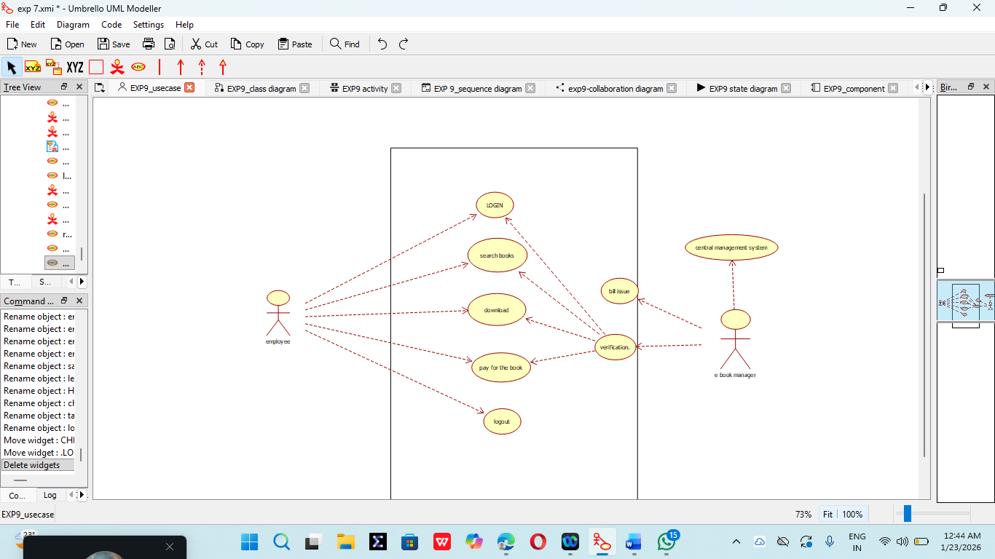

2. CLASS DIAGRAM:
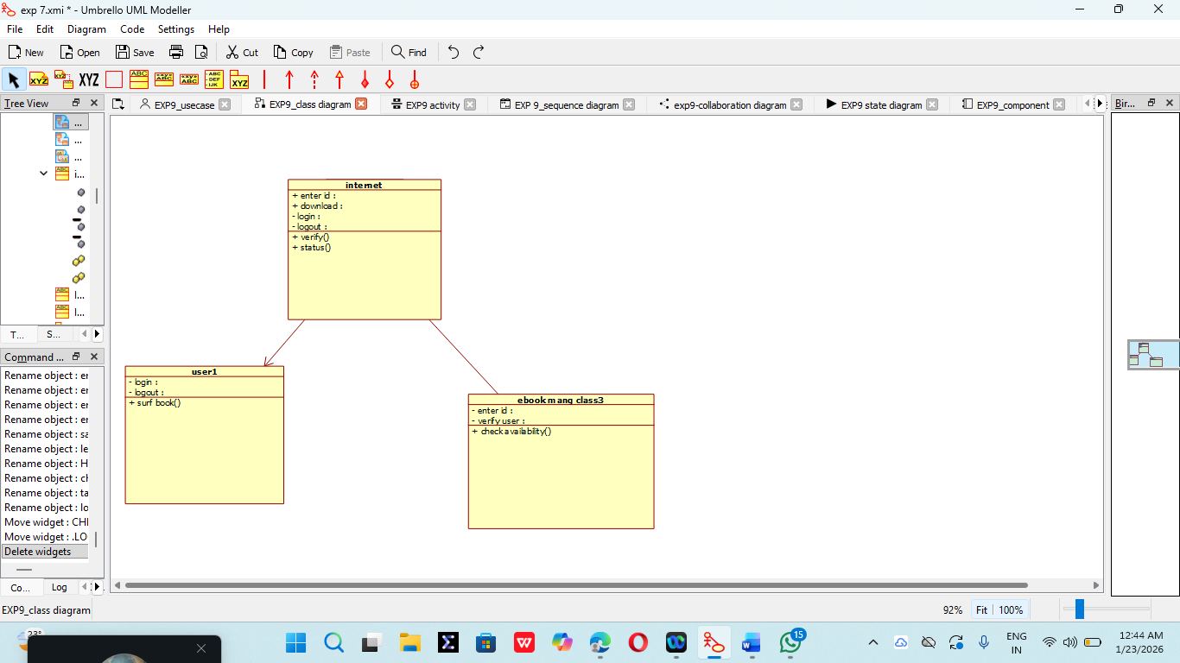
3. ACTIVITY DIAGRAM:
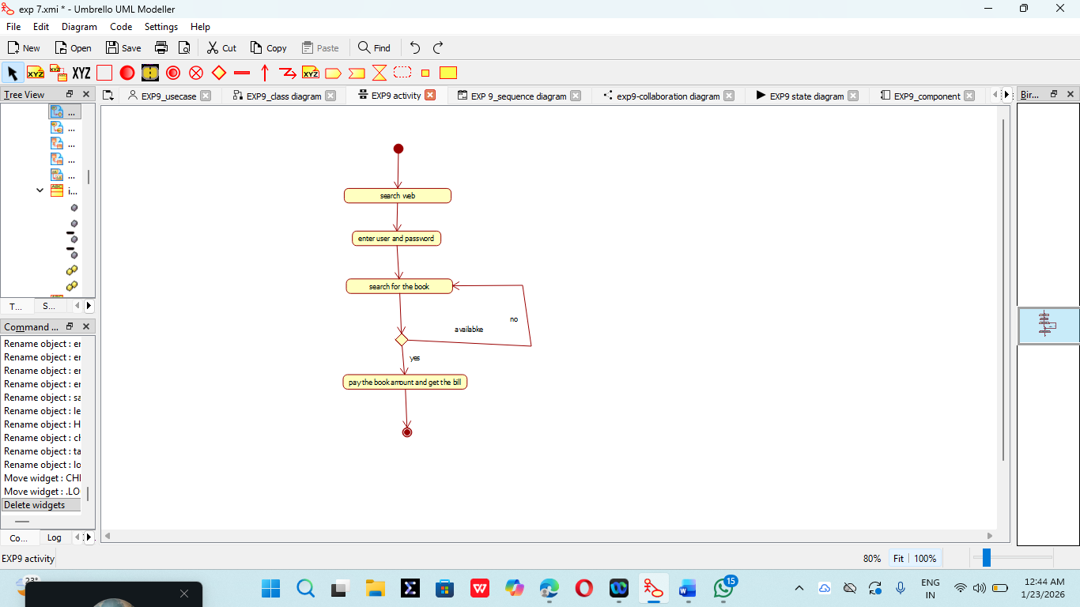

4. SEQUENCE DIAGRAM:
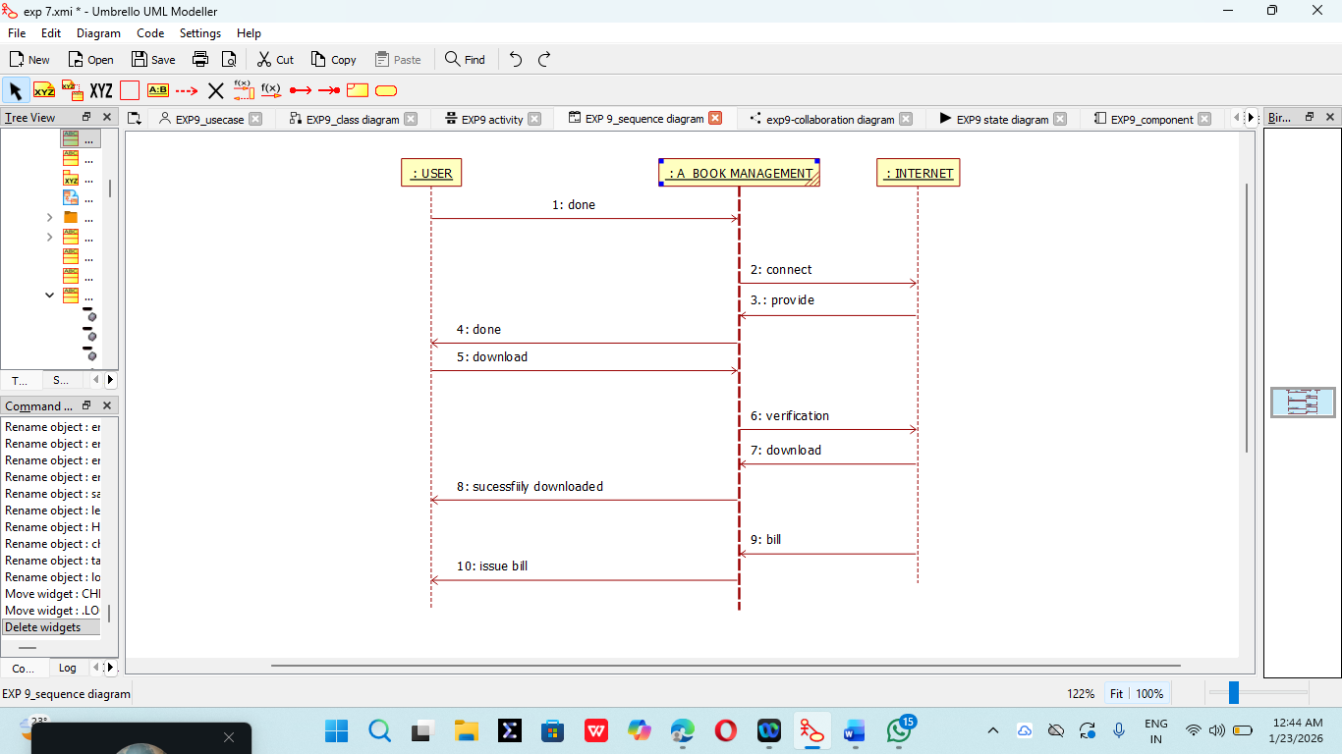

5. COLLABORATION DIAGRAM:
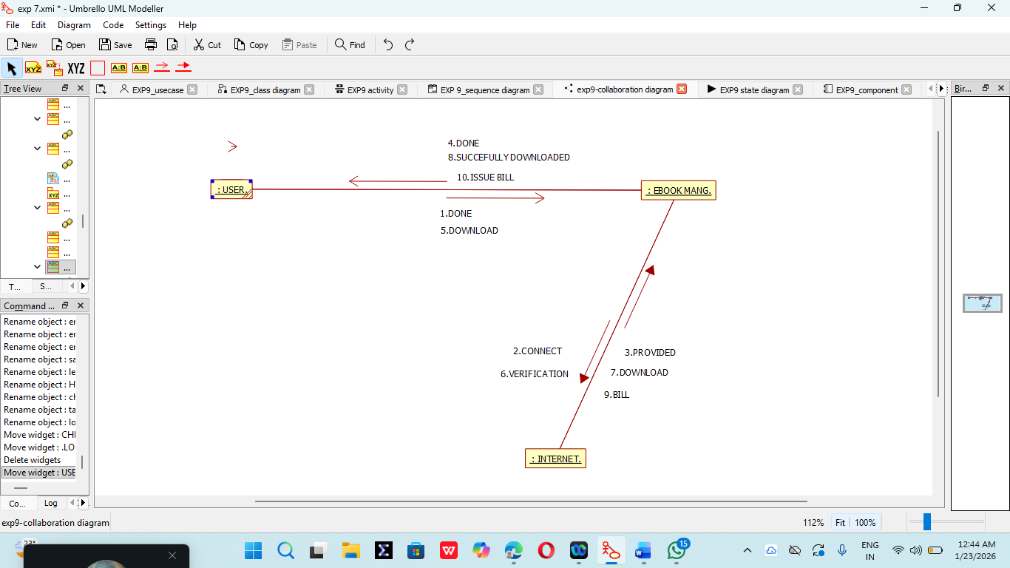
6. STATE CHART DIAGRAM:

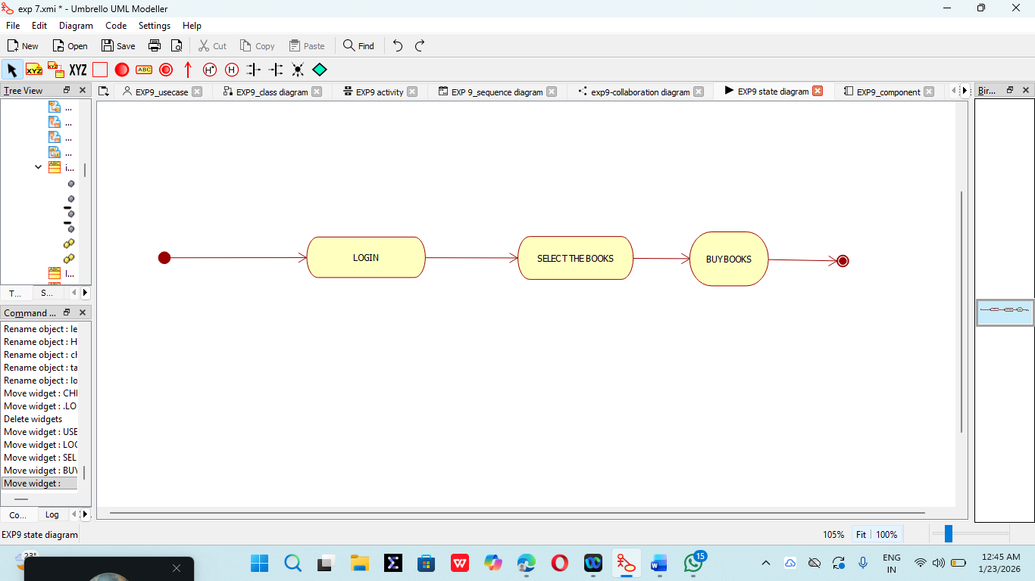

7. COMPONENT DIAGRAM:

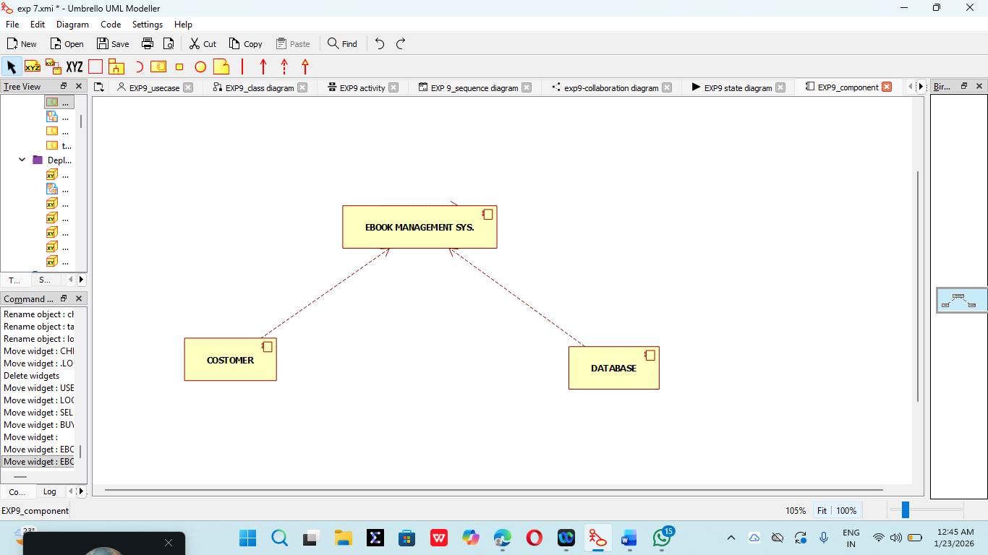
8. DEPLOYMENT DIAGRAM:
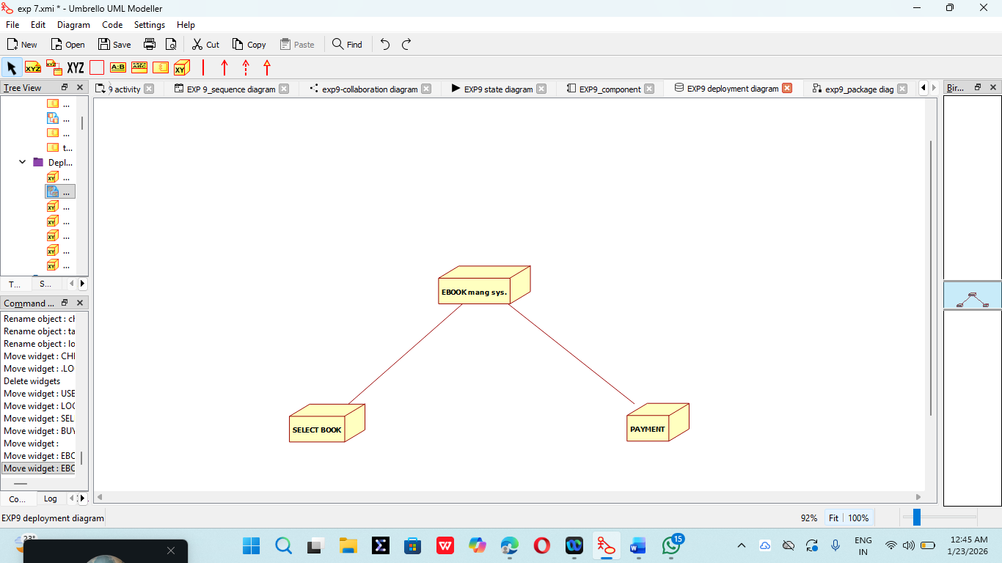

9. PACKAGE DIAGRAM:

